War Zone LINEMAN Challenge
Coach,
I would like to invite you to the 5th Annual War Zone Lineman
Challenge. The event will take place on the turf at Leonard George
Stadium on the campus of Spring HS. This event will be an opportunity
for your LINEMAN to showcase their abilities as a team in drills specific
to their position.
Last year was extremely competitive with 22 schools bringing BIG BODIES
from all around Houston to find out who the most dominate unit was!
Huge congrats to our 2019 Champion Houston Lamar and Coach Scholz!
If you are interested in joining us for this, please contact me to reserve
a spot for your team. I am confident this will be a huge success and an
exciting environment for the big bodies to compete in!

GENERAL INFORMATION:

WHERE:
Leonard George Stadium – On the campus of Spring High School (19428 I-45, Spring, TX 77373)
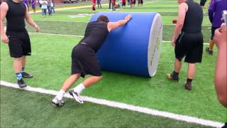
WHEN:
Saturday, June 13th 2020
Registration: 7:45 – 8:30am
Coaches meeting: 8:30am PowerDrive
Challenge will begin promptly at 9am

EVENTS: (SUBJECT TO CHANGE)
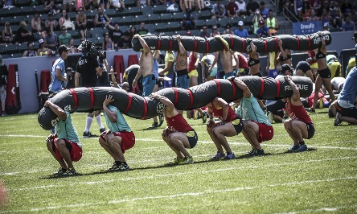
- Tire Flip Relay – timed – total for 6 team members
- KB Stack Relay (similar to atlas stone) – timed – total for 6 team members
- PowerDrive Push – timed – total for 6 team members
- Worm Carry – timed – 6 members compete at same time
- Obstacle Course – timed – total for 6 team members
- Bench Press – Reps – total for 6 team members (225-5 pts, 205-3 pts, 185-1 pt)
  - Each team must have 2 per weight Worm
- Farmers Walk – timed – total for 6 team members
- Tug of War (team event) – 6 members compete – Single elimination

**A list of event descriptions will be sent to you before the challenge.

**POINTS WILL BE KEPT AT EACH EVENT – TOP 3 WILL BE GIVEN A TROPHY! **

COST: CASH ONLY PLEASE
$20 per competitor
Athletes will be given a Dri-Fit T-Shirt

Team Format:

There is a minimum of 6 athletes per team. You can have as many as you want on a team, however, only 6 members compete per event. You are welcome to bring more than 1 team. Competitors MUST be OL/DL type athletes only!

Supplies:

Athletes need to bring gloves, sunscreen, flats, cleats and anything else they may need. There will be a trainer and water on site, however, you are encouraged to bring your own water.

Contact Info:

When you are ready to commit to the challenge let me know ASAP so I can secure your spot. Due to desired quality of event, space is limited! If you have any questions please feel free to contact me.

Brian Fitzgerald - bfitzger@springisd.org
832-457-3909 – Cell
281-891-7000 – School
thewarzone.us

SCHOOL INFORMATION SHEET EMAIL TO ME ASAP @ BFITZGER@SPRINGISD.ORG

SCHOOL NAME ____________________________ SPONSOR ACCOMPANYING TEAM ______________________________

ATHLETE NAME SHIRT SIZE LIABILITY FORM PAID

1. _____________________________________ __ ________ _______ _________ ______

2. _______________________________________ __________ ________________ _______

3. _______________________________________ __________ ________________ _______

4. __________________________________ ____

5. _____________________________________ __

6. ______________________________ _________

7. ______________________________ _________

8. ______________________________________ _

9. _____________________________________ __

10._____________________________________ __

Insurance Waiver
***Please make copies and bring the day of the event. In order for your child to participate in the 2019 War Zone Lineman Challenge, it is necessary to sign this statement indicating your understanding that the district does not carry insurance covering injuries your child may sustain.

The undersigned are the parent or legal guardians of:

________________________________________
Students Name

SISD WAIVER

I hereby authorize the directors of War Zone Lineman Challenge to act for me in accordance with their judgment in any emergency requiring medical attention. I further waive and release Spring Independent School District from liability for any damages from injuries and/or illness sustained at the War Zone Lineman Challenge. I know of no medical condition which might affect my child’s ability to safely participate in the camp. I recognize the assumption of risk associated with the participation in this camp.

Parent Signature: _________________ Date:________________

