War Zone LINEMAN Challenge
“Under the Lights”
Coach,
I am excited to invite you to the 7th Annual War Zone Lineman Challenge. This
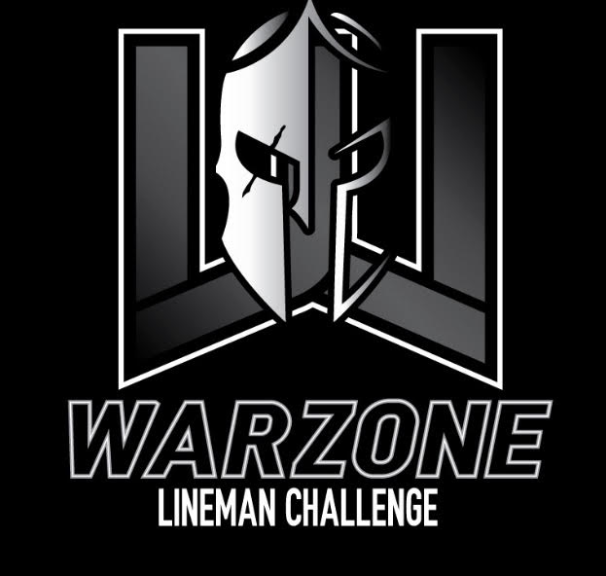
year we want to change it up. We will compete Friday evening under the lights.
There is no other position in football more important than the Big Bodies
in the trenches. I firmly believe competition drives excellence and that
IRON SHARPENS IRON. I want my guys competing against the best, as I’m
sure, you do as well. Join us for the battle of H-Town big bodies!
The event will take place on the turf at Wildkat Stadium on the campus of
Willis High School. This event will be an opportunity for your LINEMEN
to showcase their abilities as a team in drills specific to their position.
Last year was extremely competitive with BIG BODIES from all around
Houston coming to find out who the most dominate group was!
If you are interested in joining us this year, please contact me to reserve
a spot for your team. I am confident this will be a huge success and an
exciting environment for the Big Bodies to compete in!
*This is the official Houston Qualifier for the Hardin Simmons State Lineman Challenge on June 24th. Top 4 teams qualify.

GENERAL INFORMATION: Website – www.thewarzone.us

WHERE:
Wildkat Stadium (renovated and turfed in 2022) – On the campus of Willis High School (10005 TX-75, Willis, TX 77378)

WHEN:
Friday, June 9th 2023
Registration: 4:00pm-5:15pm
Coaches meeting/dinner: 5:30pm PowerDrive
Challenge will begin promptly at 6pm

EVENTS: (SUBJECT TO CHANGE) **A list of event descriptions will be sent to you before the challenge.
- Tire Flip Relay – timed – total for 5 team members
- KB Stack Relay (similar to Atlas Stone) – timed – total for 5 team members
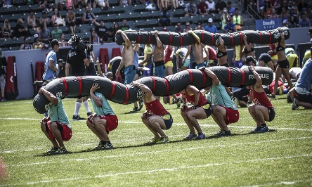
- PowerDrive Push – timed – total for 5 team members
- Worm Carry – timed – 5 members compete at same time
- Obstacle Course – timed – total for 5 team members
- Bench Press – Reps – total for 5 team members (225-5 pts, 205-3 pts, 185-1 pt)
  - Max 2 athletes per weight w/ 1 weight having 1 athlete
- Farmers Walk – timed – total for 5 team members
- Sled Push/Pull – timed – total for 5 team members Worm
- Tug of War (team event) – 5 members compete – Single elimination
**POINTS WILL BE KEPT AT EACH EVENT – TOP 3 WILL BE GIVEN A TROPHY! **
COST: CASH ONLY PLEASE
$20 per competitor
Athletes will be given a Dri-Fit T-Shirt

Team Format:

There is a minimum of 5 athletes per team. You can have as many as you want on a team, however, only 5 members compete per event. You are welcome to bring more than 1 team. Competitors MUST be OL/DL/TE type athletes only!

Supplies:

Athletes need to bring gloves, sunscreen, flats, cleats and anything else they may need. There will be a trainer and water on site, however, you are encouraged to bring your own water.

Contact Info:

When you are ready to commit to the challenge let me know ASAP so I can secure your spot. Due to desired quality of event, space is limited! If you have any questions please feel free to contact me.

Brian Fitzgerald – bfitzgerald@willisisd.org
832-457-3909 – Cell
936-856-1250 – School
thewarzone.us

To sign your team up, please fill out the google form below:

https://docs.google.com/forms/d/e/1FAIpQLSfWhb0TJCzfwtwyGyOm6VjMxhjAcArRKJu0BiHZkeW3NAMBVg/viewform?usp=sf_link

Insurance Waiver
***Please make copies and bring the day of the event. In order for your child to participate in the 2023 War Zone Lineman Challenge, it is necessary to sign this statement indicating your understanding that the district does not carry insurance covering injuries your child may sustain.

The undersigned are the parent or legal guardians of:

________________________________________
Students Name

WISD WAIVER

I hereby authorize the directors of War Zone Lineman Challenge to act for me in accordance with their judgment in any emergency requiring medical attention. I further waive and release Willis Independent School District from liability for any damages from injuries and/or illness sustained at the War Zone Lineman Challenge. I know of no medical condition which might affect my child’s ability to safely participate in the camp. I recognize the assumption of risk associated with the participation in this camp.

Parent Signature: _________________ Date:________________

